Introduction to Section 2
Symbiosis

Time and time again in nature, we witness two or more organisms living together in harmony, sharing some sort of physiological interaction. Images of clown-fish hiding from predators in sea anemone in exchange for the fishes' protection and nutrient-rich excrement may come to mind, or maybe a monarch butterfly pollinating flowers (Fig. 7.1). However, we need not look beyond ourselves to find symbiotic relationships. There are far more non-human cells on and in the human body than actual human cells. This is due to the numerous bacteria, achea, fungi, and viruses found on and within our bodies. This microbiome is increasingly recognized to perform a variety of functions for humans. The microbiome is involved in digestion and essential nutrient production, protection against pathogens, and is even implicated in our mental well being.
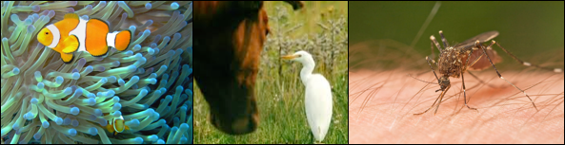

Figure 1. Common symbiosis examples (left to right) of mutualism: clownfish getting protection from anemone in exchange for nutrients (from fish excrement), commensalism: unaffected cattle graze on grassland, disturbing soil and exposing insects for the egret to come eat and parasitism: a mosquito sucks blood from animals as a food source while the host is injected with saliva that could potentially be housing many different diseases.

Symbiosis refers to two or more unlike organisms interacting physiologically. Some microbiologists do not consider associations like the clownfish and the anemone a symbiosis in the literal sense of the word because, while they do benefit each other, they do not directly interact physiologically. However, most modern discussions of symbiosis, especially among animal biologists, often include the non-physiological, behavioral interactions if organisms of different species form persistent biological interactions (such as among clownfish and sea anemones).
There are three typical symbiotic relationships that are observed; mutualism, commensalism, parasitism. It is a common misconception that symbiosis refers to only beneficial interactions, or mutualisms; these are interactions where both organisms involved are benefiting from these evolutionary partnerships. Rather, symbiosis encompasses parasitic and commensal interactions as well. Often these relationships are dynamic in their benefits and costs to the organisms involved and are dependent on changing circumstances of the environment and life stage of the symbionts as to where along the continuum of symbioses they may be classified.
The interacting organisms usually have coevolved with each other over generations, influencing their lifestyles through selective pressures and shaping how they both live. Symbiotic interactions have been evolving for billions of years and are constantly evolving to this day. For this section, we are going to be discussing mutualisms between the Cannabis plant and members of the Kingdom Fungi.
Microbes are ubiquitous throughout all ecosystems. They interact with all organisms, causing animals and plants to get sick, while others keep those same groups healthy. They are found in outstanding numbers in the air and soil all around us. In fact, with every breath we take we are inhaling an incredible amount of spores and cells and then exhaling them. Soil scientists have determined that there are more organisms in a gram of soil than there are humans on the planet. (10,000,000,000 bacterial cells per gram soil, population of earth July, 2018 ~7,600,000,000) (Raynaud & Nunan, 2014). Microbes play a variety of roles in all ecosystems and the resulting microbiomes of every complex macroscopic organism are crucial for maintaining homeostasis. As such, many soil organisms interact both directly and indirectly with Cannabis plants.
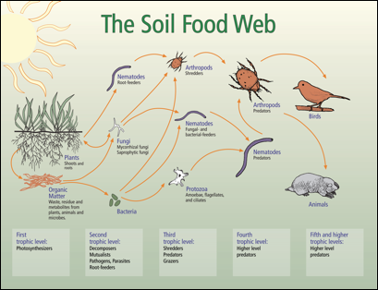
Fig. 2 Soil food web interaction diagram. Different trophic levels will consume lower levels and excrete waste in the form of plant available nutrients.

Fungi found in the soil that may directly interact with Cannabis include mycorrhizal fungi, such Funneliformis and Rhizophagus species. Soil saprophytic fungi, ranging from mushroom-producing decomposers to the more covert ‘molds,’ are ubiquitous and benefit crops by playing important roles in nutrient cycling, water retention, and the ecological state of the soil microbiome ( Fig 7.2.). On the opposite side of the spectrum, fungal pathogens lurk, waiting for the right conditions and opportunities to exploit susceptible plants. Most commonly, pathogens will infect weak plants and only certain individuals within a given population. However, some pathogens will cause devastating disease and the outright physical destruction of entire fields of crops, if not only the loss of any economic value.

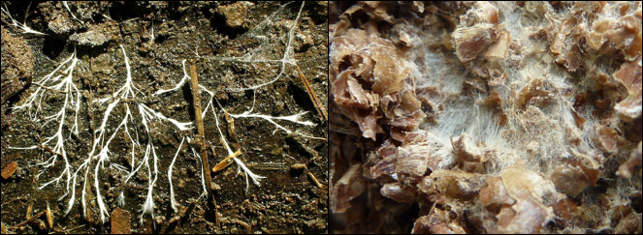
Figure 3. Fungal mycelium growing in soil, digesting organic matter and releasing bioavailable nutrients.

Entomopathogenic fungi are fungi that grow on and metabolize insects or arthropods as a food source. The fungus will consume the host and then will produce a reproductive structure to release spores with the goal of infecting other insect and arthropod hosts. Some of these fungi may be utilized by farmers or naturally act as biological control agents active against insect pathogens Cannabis. Entomopathogenic fungi can infect aphids, thrips, whiteflies, and other agricultural pests, but also beneficial insects. Some lineages of entomopathogenic fungi may also exist as plant endophytes where they often exert plant growth promoting effects on the host. Even then, they may also cause damage such as the aborting of grain to be replaced by fungal sclerotia as in Ergot (Claviceps sp.) and Corn smut (Ustilago maydis).
All of these are examples of symbiotic relationships where two or more different organisms are interacting physiologically and impacting the growth and fitness of each other. The primary goal of ‘The Mycology of Cannabis’ is to outline the various symbioses that Cannabis has with the Kingdom Fungi -starting with mutualisms, touching on commensalisms, and ending with parasitisms- with an eye toward the potential for farmers to utilize this information to their advantage. The diverse manner in which fungi interact with Cannabis play key roles affecting all aspects of cultivation and processing Cannabis.

